Time | Name | Phone Numbers | 3/9/14 | 3/16/14 | 3/23/14 | 3/30/14 | 4/6/14 | 4/13/14 | 4/20/14 | 4/27/14 | 5/4/14 | 5/11/14 | 5/18/14 | 5/25/14 | 6/1/14 | 6/8/14
4 | Buttigieg, Emily | 313.320.8538 |  |  | 2 |  |  |  |  |  |  |  | 1
4 | Buttigieg, Hannah | 313.320.8538 |  |  | 1 |  |  |  |  |  |  |  | 2
4 | Feldt, Jim | 313.244.1337 | 2 |  |  |  | 1 |  |  |  |  | 2
4 | Gillis, Eric | 313.492.8687 |  | 2 |  |  |  |  |  | 1 |  |  |  | 2
4 | Kohn, Mike | 734.667.1393 |  |  |  |  |  | 1
4 | Lefforge, Sherrill | 313.537.0570 |  | 1 |  |  |  | 2 |  |  |  |  |  |  |  | 1
4 | Nemeth, Yvonne | 313.740.7721 |  |  |  | 2 |  |  |  |  |  |  |  | 1
4 | Sinelli, Nancy | 248.561.0539 |  |  |  | 1 |  |  |  | 2 |  |  |  |  | 1
4 | Trewyn, Noreen | 313.689.0006 | 1 |  |  |  | 2 |  |  |  | 1 |  |  |  | 2
4 | Wendt, Alan | 313.657.4564 |  |  |  |  |  |  |  |  | 2
4 | Wojcik, Sr. Margretta | 313.534.9000 |  |  |  |  |  |  |  |  |  | 1 |  |  |  | 2
9 | Aiton, Mary Ann | 734.513.8518 | 2 |  |  |  | 1 |  |  | 2 |  |  |  | 1 |  | 2
9 | Butler, Mike | 734-953-0070 |  | 1 |  | 1 | 2 |  |  |  | 1 |  |  | 2
9 | Hebner, John | 313.533.4166 |  |  | 2 |  |  | 1 |  |  | 2 |  |  |  | 1
9 | McDermott, Antoinette | 313.255.9676 |  |  | 1 |  |  | 2 |  |  |  | 1 |  |  | 2
9 | Somerville, Bill | 734.522.0748 |  | 2 |  |  |  |  |  | 1 |  |  | 1 |  |  | 1
9 | Renauer, Debra | 313.729.0446 |  |  |  |  |  |  | 2 |  |  | 2
9 | Wolf, Lisa | 313-537-4765 | 1 |  |  | 2 |  |  | 1 |  |  |  | 2
11 | Genga, Sharon | 734.525.8532 |  | 1 |  |  | 2 |  |  | 1 |  |  | 1 |  |  | 1
11 | Hansen, Chris | 734.306.6028 |  | 2 |  |  | 1 |  |  | 2 |  |  | 2 |  |  | 2
11 | Hyslop, Elaine | 248.478.2834 |  |  | 1 |  |  | 2 |  |  | 1 |  |  | 1
11 | Patrick, Justin | 734.525.3100 |  |  | 2 |  |  |  | 1 |  | 2 |  |  | 2
11 | Pfeifer, Meg | 313.559.1170 | 1 |  |  | 2 |  |  | 2 |  |  | 1 |  |  | 1
11 | Syverson, Eric | 313.541.4676 | 2 |  |  | 1 |  | 1 |  |  |  | 2 |  |  | 2

Substitute - Robin Beck - 734.261.0476

Lector Creed
The Lord God has given me a well-trained tongue that I might know how to speak to the weary a word that will rouse them.
Lector Prayer
Lord Jesus, come in the Holy Spirit and enlighten my mind that I may better understand your word. Help me to be more deeply aware of your presence, that I may proclaim the word of God with a heart filled with love. Unworthy as I am, help me proclaim your words, through my lips, that I may touch the heart of all. Amen.

If you are not able to be present for the assigned liturgy, it is your responsibility to find a replacement.

Thanks

Lector Ministries
The Lector Ministry is a great opportunity to serve Our Lady of Loretto community.
Lectors experience a joy that comes through serving the Lord and others. Lectors share the Word of God by proclaiming the Scriptures at Mass. They serve God by communicating His words to the parish community.
Mass Schedule:
Saturday 4:00 pm
Sunday 9:00 am
11:00 am

OUR LADY OF LORETTO
Rectory Offices
17116 Olympia Street
Redford Township, MI 48240
Phone: 313.534.9000
Fax: 313.534.6744
Website: www.ourladyoflorettoparish.org

Our Lady of Loretto

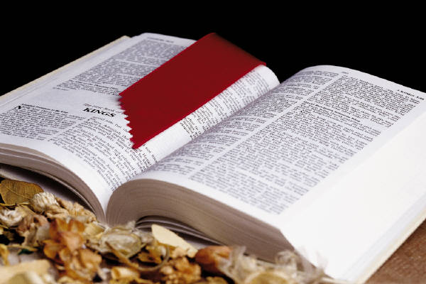

Starting Date March 9, 2014

Ending Date June 8, 2014

